CS 008A

Nicholas Hanoian and Chris McCabe

Assignment: Final Project

Video Game Database

Version <1.0>

Table Of Contents

Time Log 3

Introduction 5

Purpose 5

Definitions, acronyms, and abbreviations 5

Overall Description 5

Story Board 6,7,8,9,10

Specific requirements 11

|  |  |  |  |
| --- | --- | --- | --- |
| Time Log | | | |
| Estimated time to complete assignment => | | | 100 Hours |
| Date | Time Spent  (in hours) | Description | Author |
| 10/29 | 1 | Assigned roles, began brainstorming website ideas | Nicholas Hanoian  Chris McCabe |
| 11/5 | 2 | Decided on topic, created framework for development | Nicholas Hanoian  Chris McCabe |
| 11/8 | 3 | Created structure for site | Nicholas Hanoian |
| 11/9 | 1.5 | More work on site structure | Nicholas Hanoian |
| 11/9 | 1 | Site design | Chris McCabe |
| 11/13 | 2 | Created color function for rating | Nicholas Hanoian |
| 11/13 | 1.5 | CSS work for side box | Nicholas Hanoian |
| 11/19 | 6 | JS Slider: getting filenames, designing slider | Nicholas Hanoian |
| 11/25 | 3.25 | Styling nav (top&side) and game/home pages | Chris McCabe |
| 11/26 | 0.5 | Fixing nav css | Nicholas Hanoian |
| 12/2 | 3 | Changed css and added breadcrumb nav | Nicholas Hanoian |
| 12/2 | 3 | Added more game content(csv, images) | Chris McCabe |
| 12/2 | 1 | CSS styling (color scheme consistency) | Chris McCabe |
| 12/3 | 2.5 | Added more game content(csv, images) | Chris McCabe |
| 12/3 | 6 | Worked on site structure (footer scalability) | Nicholas Hanoian |
| 12/4 | 1 | Styled footer | Nicholas Hanoian |
| 12/5 | 6 | Added content to homepage (recent games), added images on side of page, genre page sorts games alphabetically | Nicholas Hanoian |
| 12/5 | .5 | Editing CSS | Chris McCabe |
| 12/6 | 2 | Worked on responsiveness of images on side of page | Nicholas Hanoian |
| 12/6 | 6 | Created ‘about’ page, color scheme change and other CSS | Nicholas Hanoian |
| 12/6 | 1 | Adding game content(csv, images) | Chris McCabe |
| 12/7 | 4 | Adding game content(csv,images) | Chris McCabe |
| 12/7 | 1 | Editing logo and icon image | Nicholas Hanoian, Chris McCabe |
| 12/7 | 4 | Proofreading about page, adding more characters, removing divs | Nicholas Hanoian |
| 12/7 | 2 | Finalizing site | Nicholas Hanoian,  Chris McCabe |
|  |  |  |  |
|  |  |  |  |
|  | 70.75 | <=Total Time Spent |  |
|  |  |  |  |

# Introduction

### Purpose

The purpose of this document is to describe the requirement specification for the web site “Video Game Database”.

The intended audience for this document is course instructor, Bob Erickson

### Definitions, acronyms, and abbreviations

Website design and data: [https:/nhanoian.w3.uvm.edu/cs008/cs008-final/about.php](https://cmccabe2.w3.uvm.edu/cs008-final/about.php)

VGDB – Video Game Database

Xbox – refers to Xbox One and in some cases Xbox 360

Playstation- refers to Playstation 4 and in some cases PS3

Action games-Intense gameplay usually with some violence

Roleplay games-taking the place of a fictional character and completing quest

Sports games-playing virtual version of a sport, fictional or real

# Overall Description

This site was designed to hold a collection of overviews of various video games from different genres. The site consists of a Home page, 3 genre pages, a requests page to request a game, and an about page describing where the information was obtained and how it was implemented. Each game page consists of its cover art, a details box, summary, pictures and a trailer.

# Story Board

Home Page

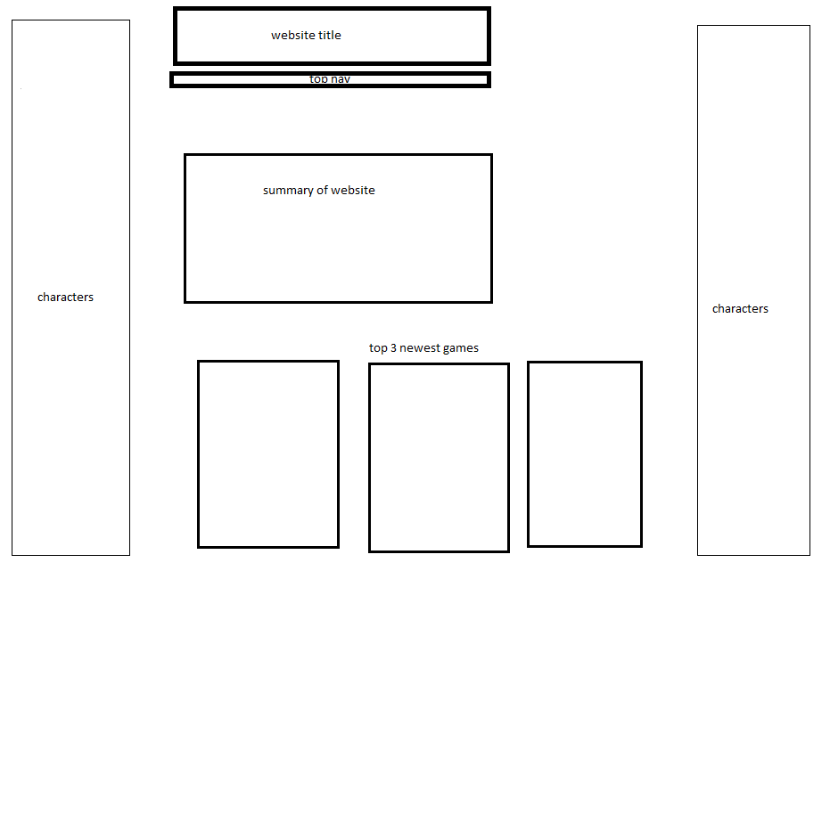

Genre Page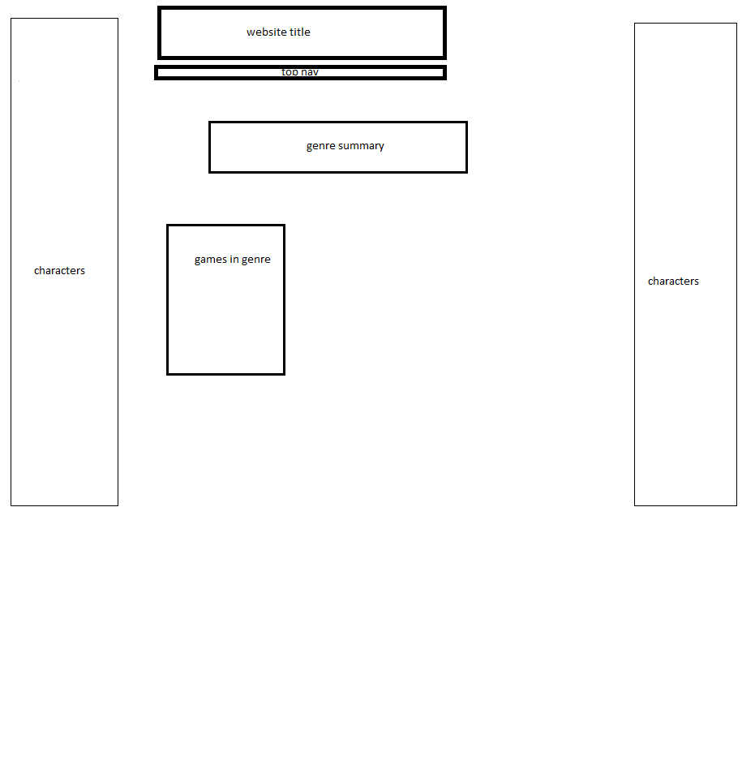

Game Page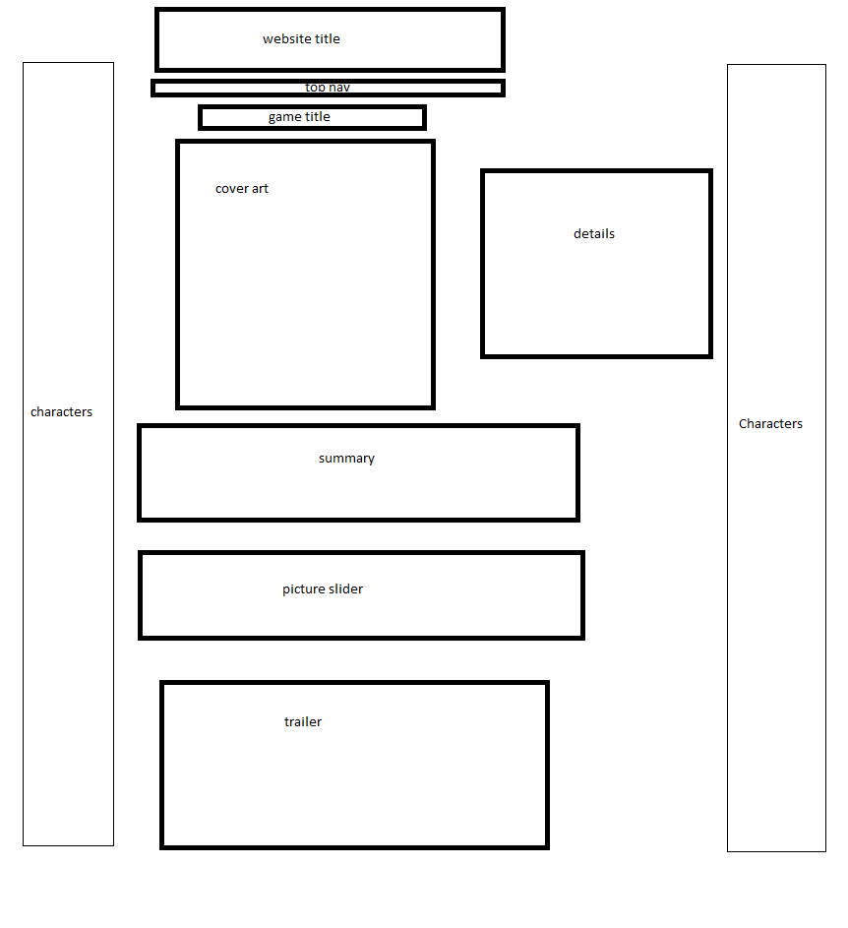

Request Page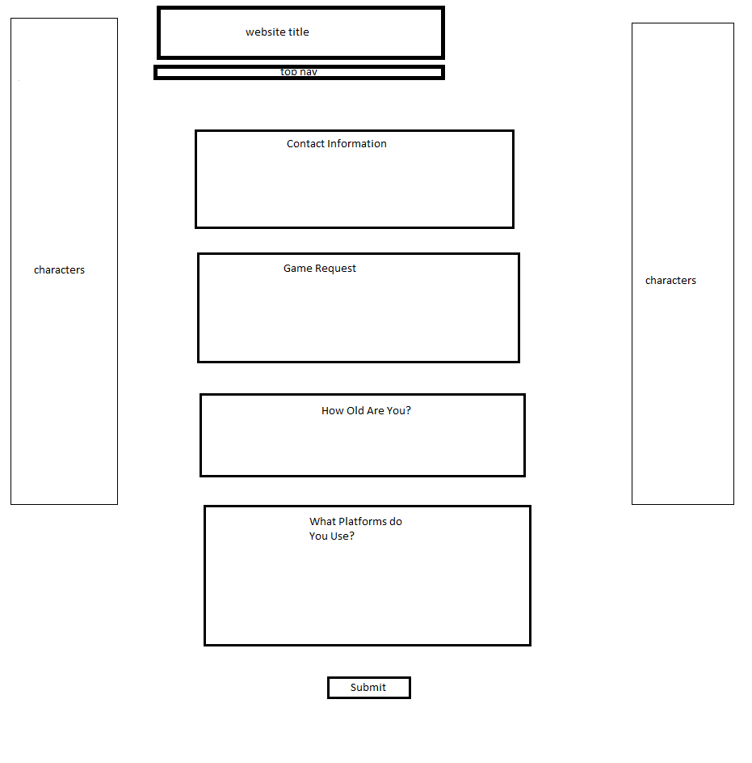

About Page

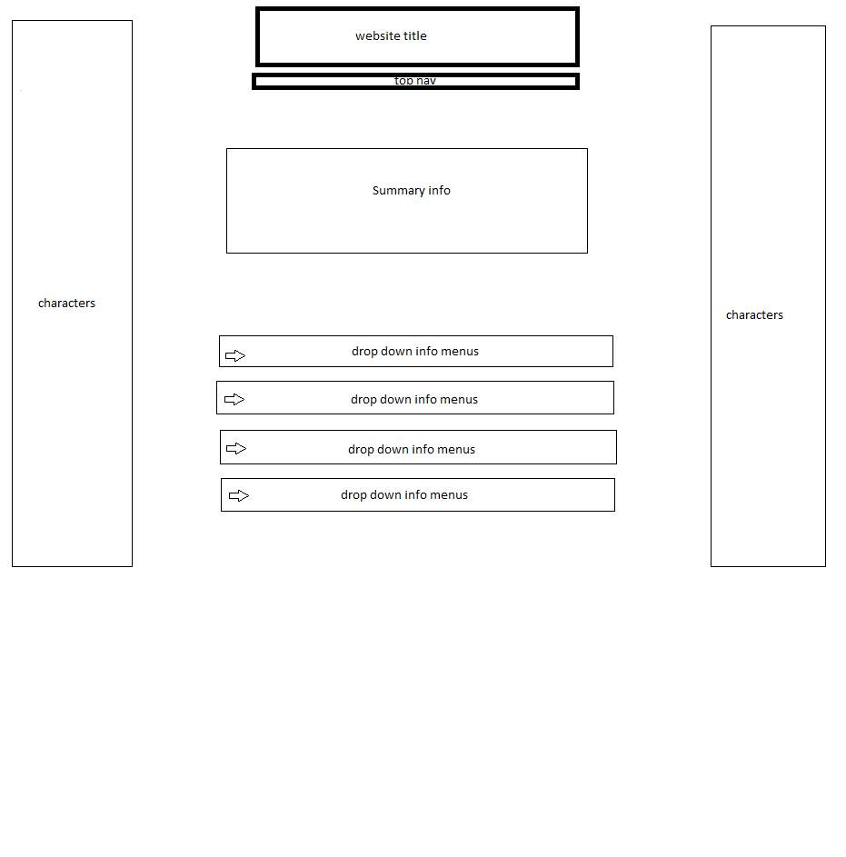

# Specific requirements

1. *Title:* *VGDB https://nhanoian.w3.uvm.edu/cs008/cs008-final/*
2. *Meta Description*: a database of video games
3. *Meta Character set*: UTF - 8
4. *Logo*: 
5. *Content can be found here*: https://www.metacritic.com
6. Images from google images specifically 1280x720
7. Trailers for video games found via youtube.com